Evil Baz’s Guide to setting up a Soldier of Fortune Server revision 1

Introduction

Many people have asked me how to set up a server to play soldier of fortune. Well, two have anyway, so this rough guide might just help in doing just that.

Ways and Means

There are many ways to set up a server, you can do it directly from the game itself by clicking the appropriate buttons, typing the correct commands into the console or you can use third party software such as SOF runner, and you can tick the selection boxes ( not the chocolatey christmas ones ) then press go.

This guide looks at using the software itself so u don’t have to down load anything.

Ok let’s go
OK, the screen on the left is typical of what you might get when you load up.
Here you enter all you usual stuff, name, set players keys, mouse etc.
I am assuming you know all about this stuff.
You want to click on the button that I’ve highlighted, if you hover the mouse pointer over the button it says ‘Create server’ and funnily enough, that’s just what we want to do ! So just jolly well click the bugger.
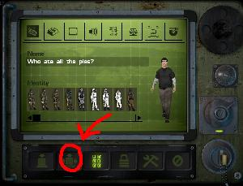
All rightee then!
You should have a screen similar to the one on the left. If not, click button ‘1’ and that will take you there.
If you click the button ‘2’ you will get to the screen below, but hold on a second. Look at the list on the right of the screenshot, I’ve called it ‘3’ and you can see a list of maps. I am currently using version 1.01 so I will have less, or possibly more map options than you unless you are using version 1.01 too.
Select that map that you want by clicking on it to highlight it.
Sweet. Nearly there.
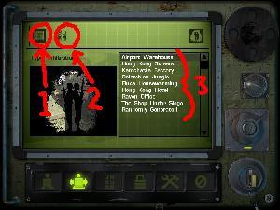
So, you have clicked the button on the top left (button ‘1’) above and now you have the screen on the left.
You’re a few clicks away from getting your server.
I have set a score limit to 50, you can click on the number 50 and enter what you want. You can set time limits etc to suit yourself.
I would recommend that you set ‘pure server’ to NO because if its is set to yes, then only people with IDENTICAL files to yours can join your server. (I think) so you might not get anyone joining.
Under dedicated if you keep clicking, it switches between NO, LAN and INTERNET. Unless you want to set up a network game for your local network only, you should choose INTERNET. You can enter a server name, max players but leave password blank or no-one can join unless you tell them the password before you set up the server.
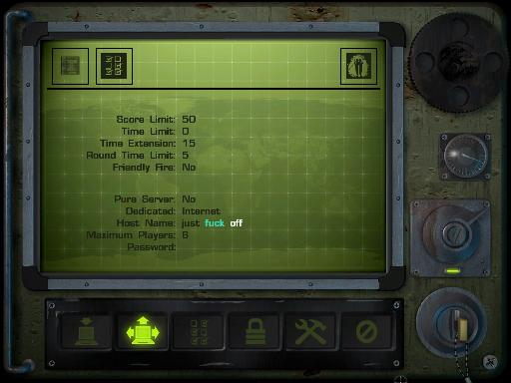

Once you have set everything to your liking as described above,
Click the button I’ve highlighted on the left, and your server will start up.
A console will open up which you can minimise and you will see loads of stuff scrolling up within the console window as the server starts up.
Then it will probably go quiet and every so often will say
“Heartbeat to ravensoft”, or something like that.

So, now you want to join in to play, right ?
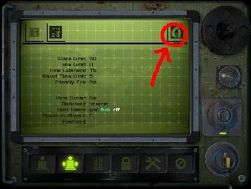

What I do next is I start SOLDIER OF FORTUNE again. So the programme is running twice. This is just like opening microsoft paint twice or having any other application open twice. Not ideal but it works for me. ☺

Then using the ‘second’ SOF application that you have opened, you can go online as normal and you should see your server, which you can join in the normal way.

However, you can look for your server on the LAN, but you should see it on INTERNET too. I usually join on LAN because I think it saves my bandwidth. I am not sure if that is correct, but it works for me.
When I get time, I will tidy up this guide and put more info on about console commands etc, but right now it is well past my bedtime and I have an early start tomorrow.

Sorry if this is shite, but it might get you going till I get more time to do this properly.

Happy fragging dudes

Baz

Addendum.

You must make sure that the relevant ports are open if you are using a router. You will have to consult your router documentation and set up the port forwarding.
Soldier of Fortune requires you to forward the 28910-28915 ports.
Here’s some links that you might find useful.

http://www.portforward.com/english/routers/port_forwarding/routerindex.htm (pick you router and follow guide)
http://www.portforward.com/cports.htm generally handy page of info
http://www.sofplayers.co.uk/tips.htm great stuff here, but no naked ladies though

If you get stuck, mail me and if I have time I might try and help.

